**Level 0 Data Flow Daiagram**

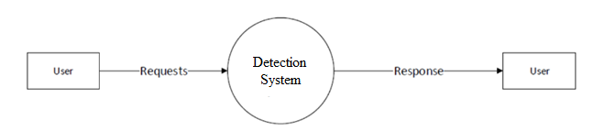

**Level 1 Data Flow Daiagram**

## 

**Level 1 Data Flow Daiagram**

